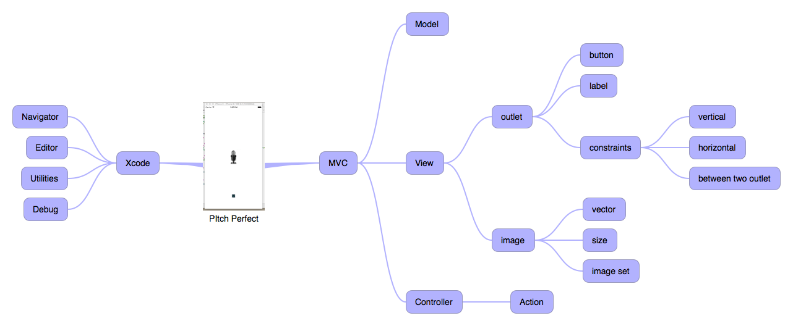

# PItch Perfect

* MVC
  + Model
  + View
    - outlet
      * button
      * label
      * constraints
        + vertical
        + horizontal
        + between two outlet
    - image
      * vector
      * size
      * image set
  + Controller
    - Action
* Xcode
  + Navigator
  + Editor
  + Utilities
  + Debug